**Course12-Colorful marquee**

****Learning goals:****

This lesson learns to use Python programming to turn the micro:bit robot's water light from left to right.

**Code：**

from microbit import *

import neopixel

display.show(Image.HAPPY)

# The water lamp is connected to pin pin16, the number is 3

np = neopixel.NeoPixel(pin16, 3)

while True:

for pixel_id in range(0, len(np)):

np[0] = (255, 0, 0)

np.show()

sleep(200)

np.clear()

np[1] = (0, 255, 255)

np.show()

sleep(200)

np.clear()

np[2] = (0, 0, 255)

np.show()

sleep(200)

np.clear()

np[0] = (255, 255, 0)

np.show()

sleep(200)

np.clear()

np[1] = (0, 255, 0)

np.show()

sleep(200)

np.clear()

np[2] = (255, 0, 255)

np.show()

sleep(200)

np.clear()

import neopixel is means to import the neopixel library function, first let the robot display a smile, then define the pin of the flow lamp as pin16, the number is 3, iterate each LED in the water lights. np[0] = ( 255, 0, 0) means that the first water light is red, and the delay is 200 milliseconds after lighting, clearing the display, lighting the second light, and so on.

**Programming and downloading：**

1. You should open the Mu software, and enter the code in the edit window, , as shown in Figure 12-1.

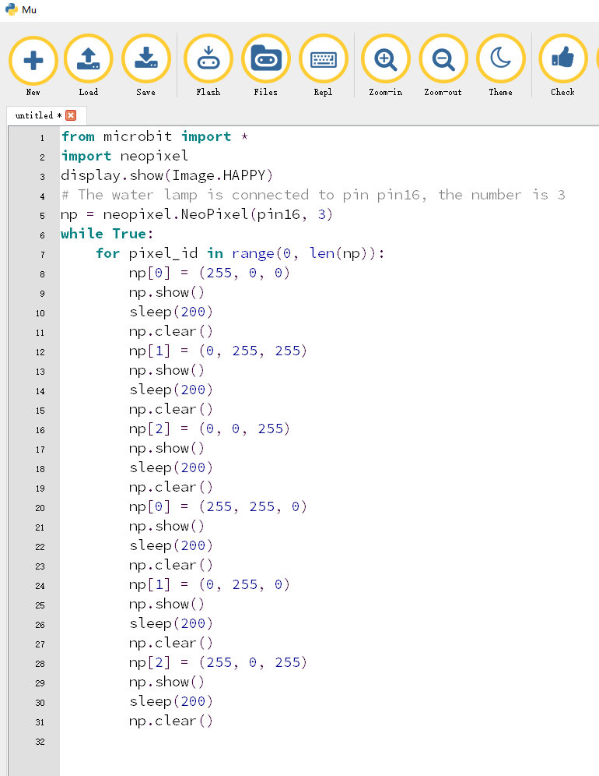

Figure 12-1

2.As shown in Figure 12-2, you need to click the Check button to check if our code has an error. If a line appears with a cursor or an underscore, the program indicating this line is wrong.

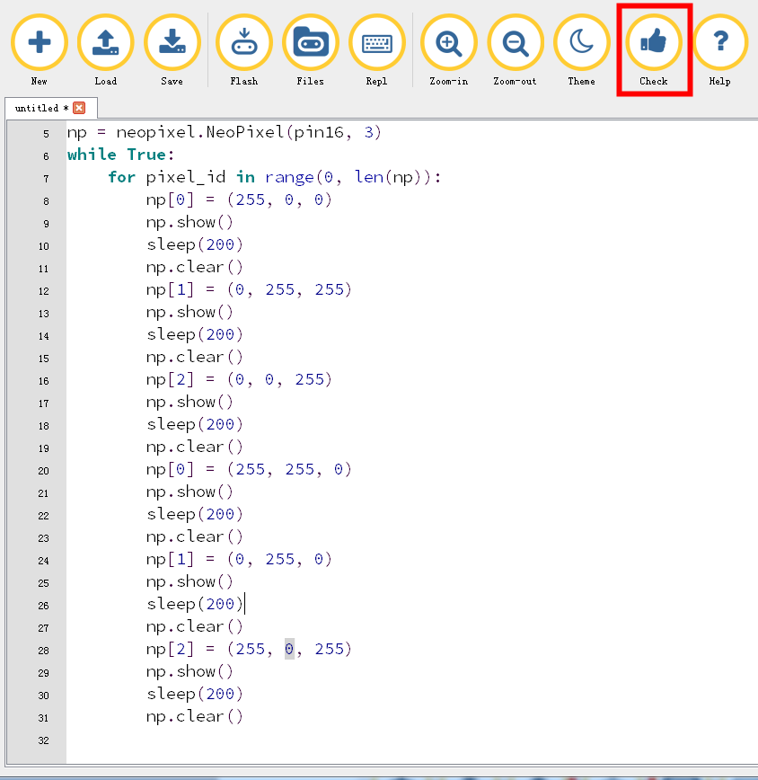

Figure 12-2

3.You need to connect the micro data cable to micro:bit and the computer, then click the Flash button to download the program to micro:bit as shown in Figure 12-3.

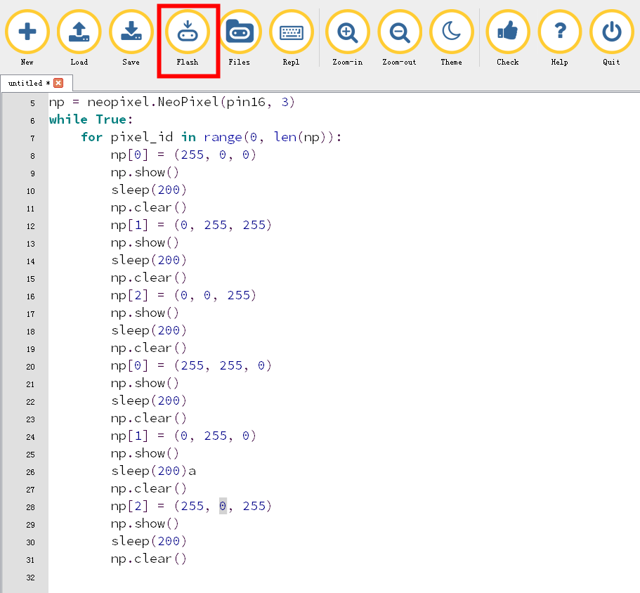

Figure 12-3

4. The schematic diagram of the robot's water lamp is shown in Figure 12-4. As you can see, the robot's flow lamp is connected to the micro:bit pin16. Therefore, we set the pin of the flow lamp to pin16 in the program. After downloading the program to micro:bit, you can see a smiley face on the robot's dot matrix and start running the marquee, as shown in Figures 12-5 to 12-7.

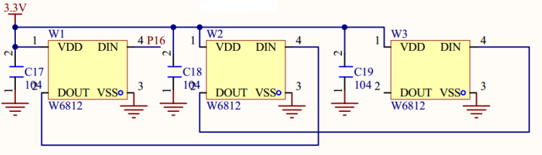

Figures 12-4

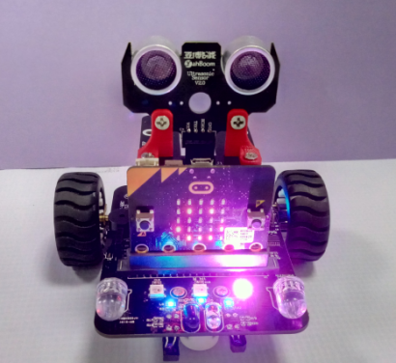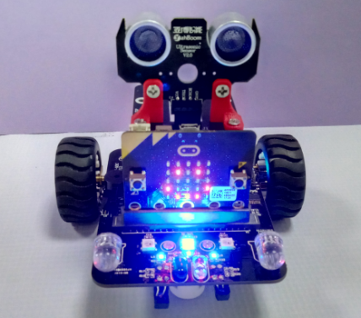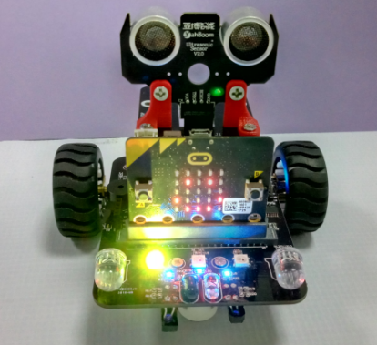

Figures 12-5 Figures 12-6 Figures 12-7